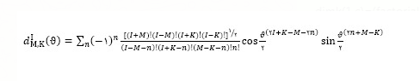
clc
clear all
I=15;
Ti=1;
K=linspace(sqrt(23),sqrt(28),10);
for h=1:10
k0=K(1,h);
thetahole=[pi/18,pi/2];
for t=1:2
dimk=zeros(1,2*I+1);
c=0;
theta=thetahole(1,t);
sigma=0;
sigmad=0;
for k=-I:I
c=c+1;
for x=0:30
u=1;
a=I-k-x;
b=I-x;
d=x-k;
if a<0 || b<0 || d<0
a=1;
b=a;
d=a;
u=0;
end
dimk(1,c)=dimk(1,c)+((-1)^x)*sin(theta/2)^(k+2*x)*cos(theta/2)^(2*I-k-2*x)/(factorial(a)*factorial(b)*factorial(d)*factorial(x))*u;
end
dimk(1,c)=(factorial(I)^2*factorial(I+k)*factorial(I-k))^.5*dimk(1,c);
sigma=sigma+exp(-k^2/(2*k0^2));
sigmad=sigmad+dimk(1,c)^2*exp(-k^2/(2*k0^2));
end
w(1,t)=(2*I+1)^2*Ti*sigmad/sigma;
end
finalratio(1,h)=w(1,1)/w(1,2)*10^-8;
end
E1=[.82 .82 .82 .82 .82 .82 .82 .82 .82 .82];
plot(K0^2,finalratio,'g',K0^2,E1,'r')
set(gcf,'color',[1,1,1])
ylabel('W(0)/W(90)')
xlabel('K0^2')

